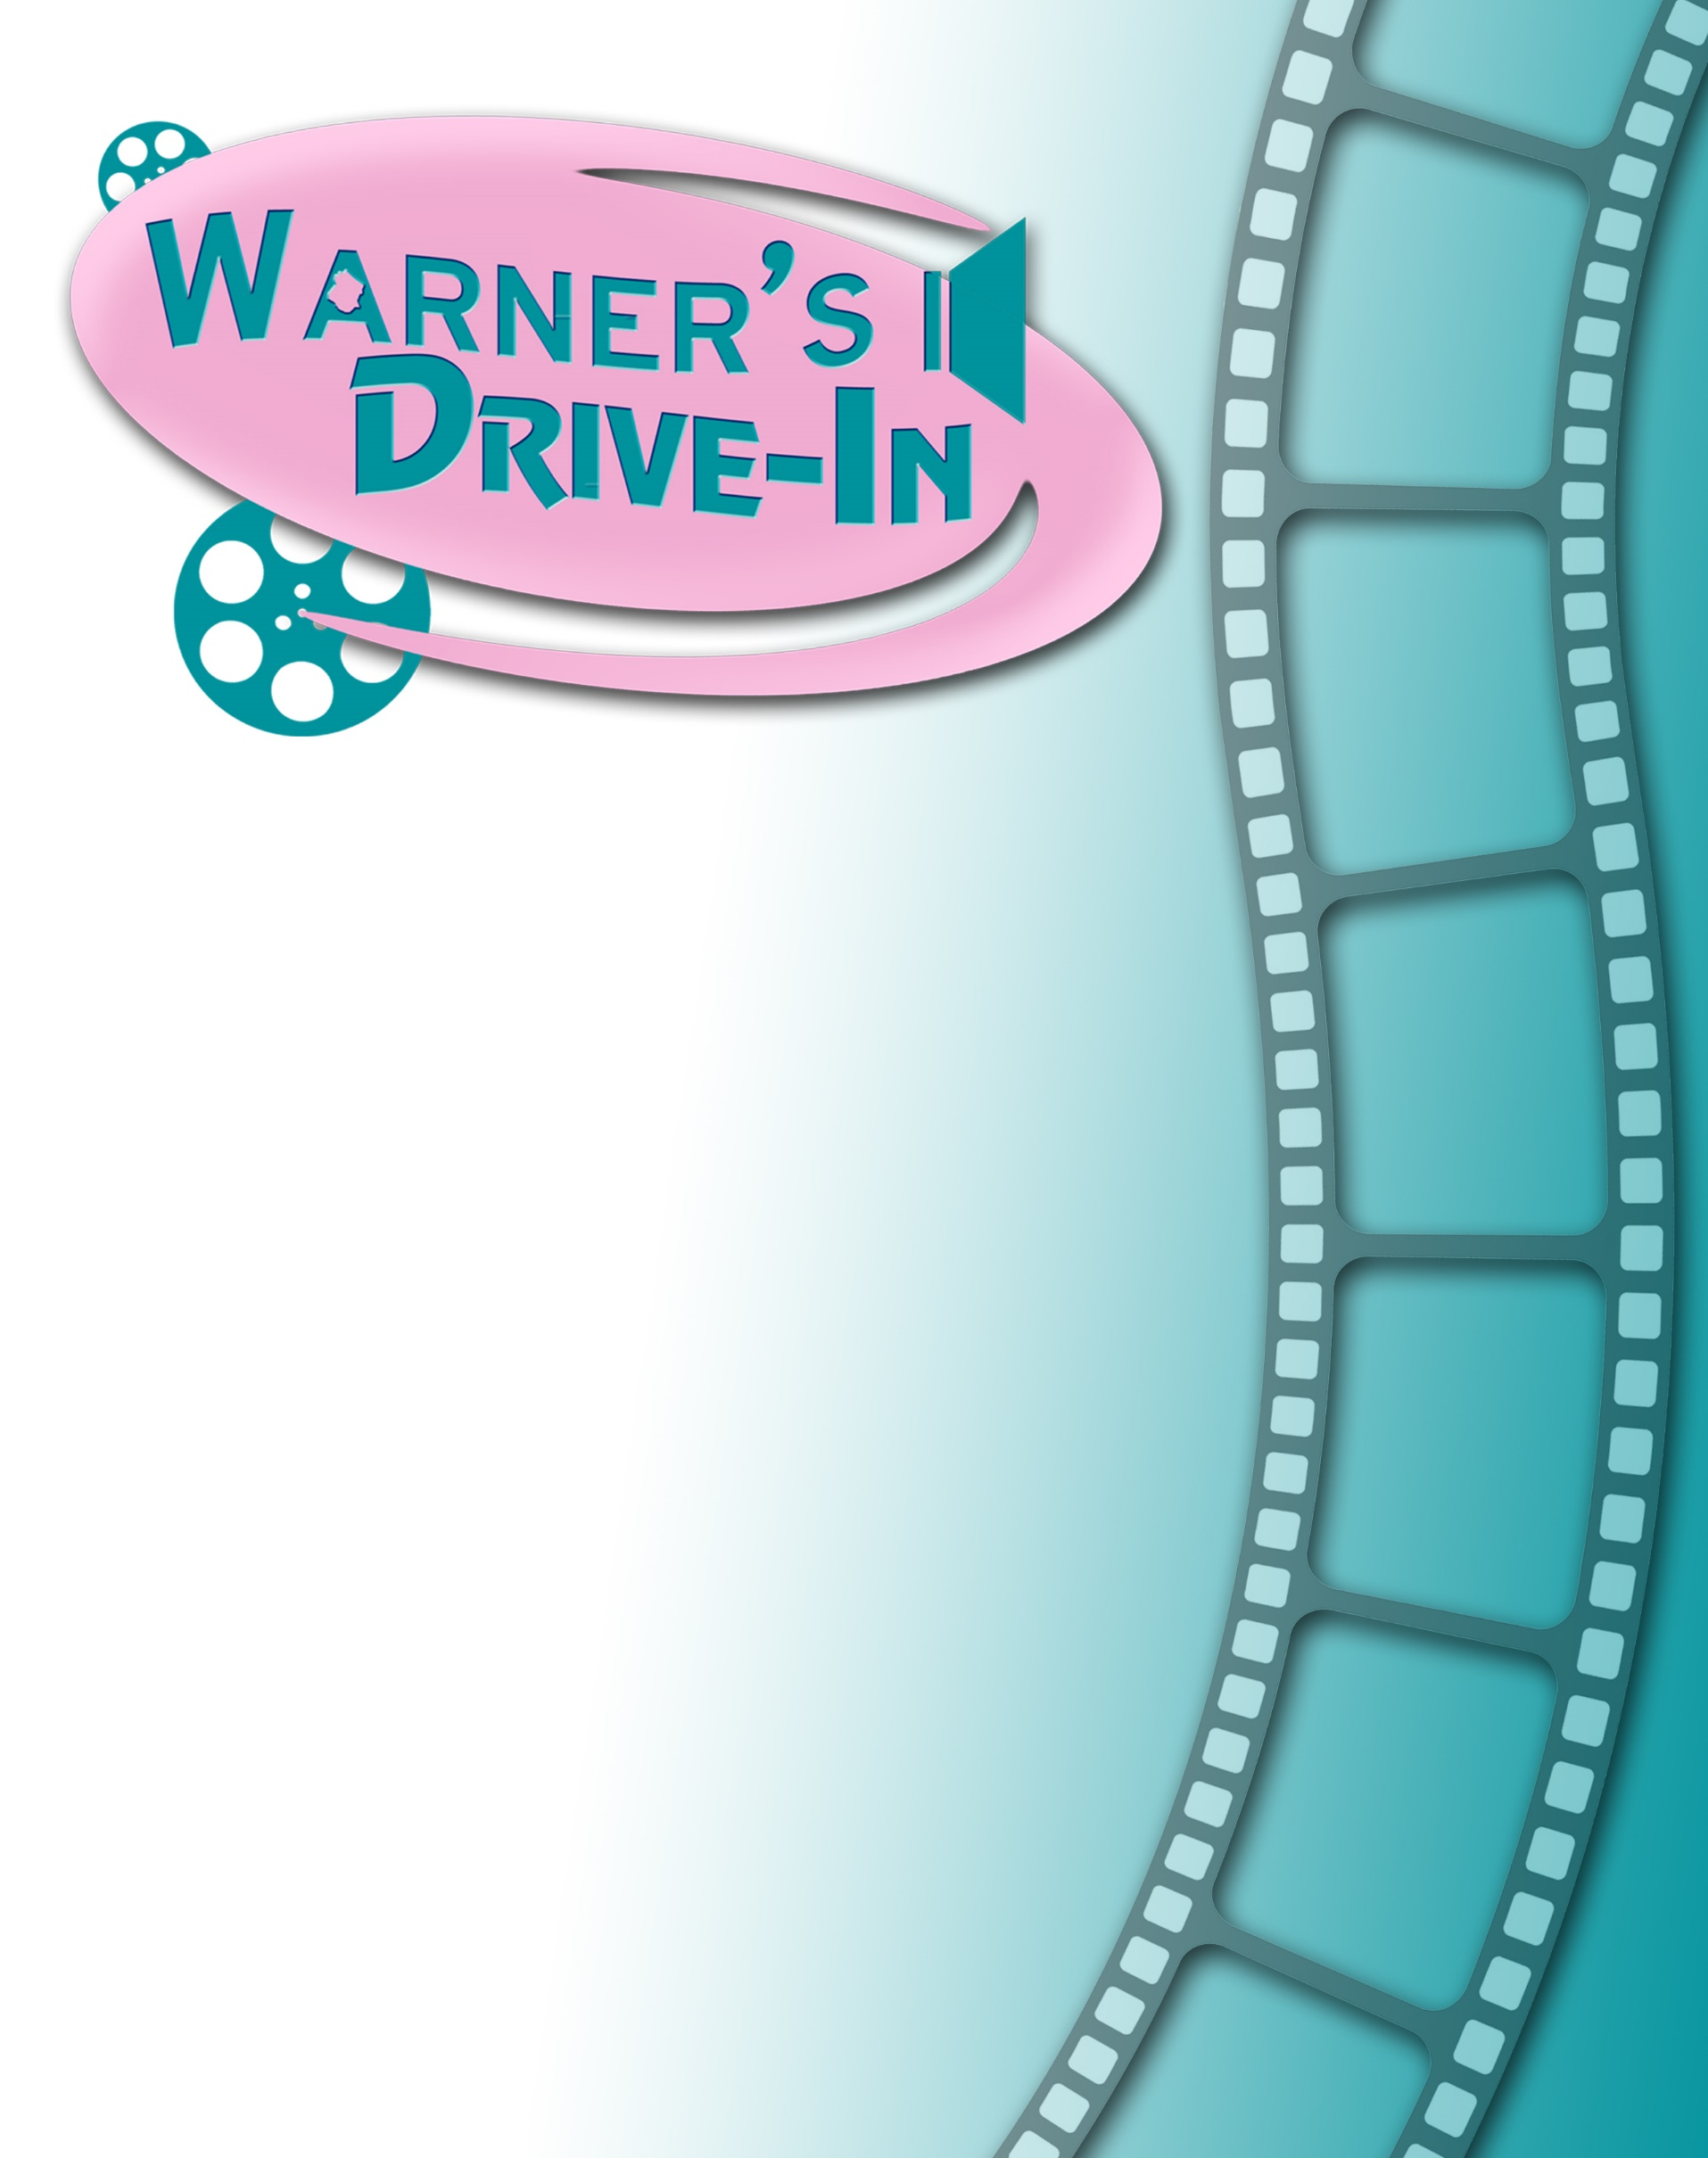

**ADVERTISE WITH WARNER’S DRIVE-IN**

**in *beautiful* Pendleton County, WV**

**2025 SummerSeason!**

*Showing movies every weekend throughout the summer*

Warner’s is the only drive-in theater in eastern West Virginia, and attracts patrons and drive-in enthusiasts from the Potomac Highlands, adjoining counties in Virginia, and as far away is Northern Virginia and Western Maryland.

**Take advantage of this popular, safe, and growing venue to advertise your business!**

Your advertising sponsorship will be part of a cherished community institution that specializes in affordable family fun and entertainment.

Warner’s is owned and operated by the Historic Warner’s Drive-In Cultural Resource Center. The Center is undertaking a major renovation of this historic landmark, with plans to extend the drive-in and provide facilities for live entertainment events.

**See details on the reverse side!**

***Warner’s Drive-In Theater***

**2025 Movie Trailer Sponsorship Application**

**SPONSORSHIP LEVEL** (check box or circle your preference)

**Platinum Level — $1,000** for full season.

• 30-second video commercial plays before every movie*.

• Logo on back of flyers given out every week.

• Link on warnersdriveinwv.org to company website (for full year).

• Mention on Drive-In’s Facebook page

• Complementary movie tickets for you, your staff, or your patrons.

**Gold Level — $500 for full season.**

• Name and/or logo displayed individually on screen before every movie for 20 seconds.

• Logo on back of flyers given out every week.

• Link on warnersdriveinwv.org to company website for full year.

• Mention on Drive-In’s Facebook page

**Silver Level — $250 for full season.**

• Name and/or logo displayed individually on screen before every movie for 10 seconds.

• Company name on back of flyers given out every week.

• Link on warnersdriveinwv.org to company website for full year.

• Mention on Drive-In’s Facebook page

**Bronze Level — $100 for full season.**

• Name and/or logo displayed individually on screen before every movie for 5 seconds.

• Company name on back of flyers given out every week.

• Link on warnersdriveinwv.org to company website for full year.

• Mention on Drive-In’s Facebook page

_ _ _ _ _ _ _ _ _ _ _ _ _ _ _ _ _ _ _ _ _ _ _ _ _ _ _ _ _ _ _ _ _ _ _ _ _ _ _ _ _ _ _ _ _ _ _ _ _ _ _ _ _ _ _ _ _ _ _ _ _ _ _ _ _ _

**Your Information:**

Name as you would like it to appear in materials: ______________________________________________

Contact Person: _____________________________________ Title: ________________________________________

Billing Address: ____________________________________________________________________________________

_______________________________________________________________________________________________________

Phone:_______________________________ Email: _______________________________________________________

Website: ____________________________________________________________________________________________

Signed: ________________________________________________________________ Date: _______________________

Payment: Enclosed Paid Through PayPal DEADLINE MAY 1, 2025

Mail to: Warner’s Drive-In

P.O. Box 974 Franklin, WV 26807

For questions email: jbasagic@gmail.com